
Lab Report 08
Data Communication & Computer Networks


Submitted To:
Engineer Shehzad Malik
Submitted By:
Sumama Rahim
F24BSCS039
BS CS (F24-A-Morning)
Date: 12/13/2025
LAB REPORT – 08
Cisco Packet Tracer – Dynamic Routing – OSPF Multiple Areas

Problem:
Make 4 router topology and do network advertised missing IPs dynamically.
Solution:
Required Resources:
- 4 Routers
- Serial 0/0 interface, Serial 0/1
Topology
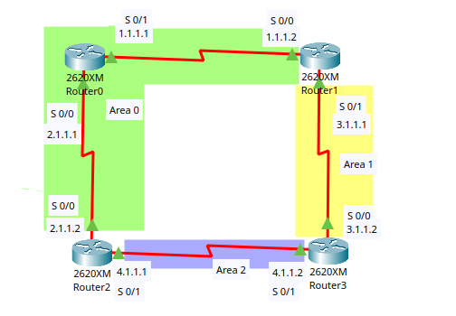
NOTE:
Addresses:
Network 1 (Router0 and Router1): S 0/0 1.1.1.1 and 1.1.1.2 (Via serial DCE cable)
Network 2 (Router0 and Router2): S 0/1 2.1.1.1 and 2.1.1.2 (Via serial DCE cable)
Network 3 (Router1 and Router3): S 0/0 3.1.1.1 and 3.1.1.2 (Via serial DCE cable)
Network 4 (Router2 and Router3): S 0/0 4.1.1.1 and 4.1.1.2 (Via serial DCE cable)
AREAS
Area 0: Network 1.0.0.0 and 2.0.0.0
Area 1: Network 3.0.0.0
Area 2: Network 4.0.0.0

Hardware Setup:
To enter serial interface, first we need to switch OFF of all routers and insert WIC-2T card in it and then switch ON.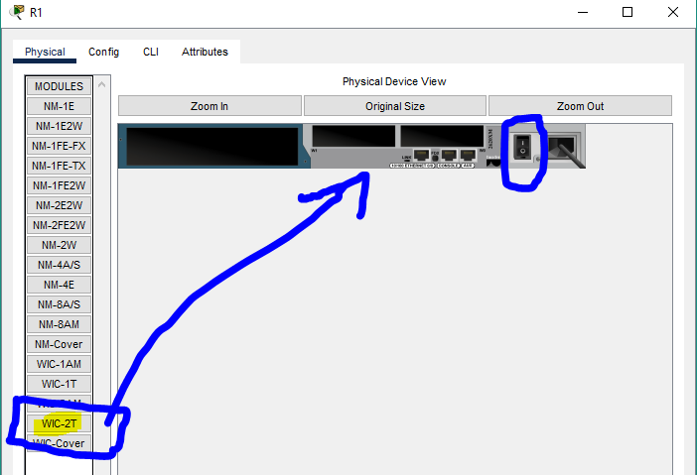

It should be inserted like this
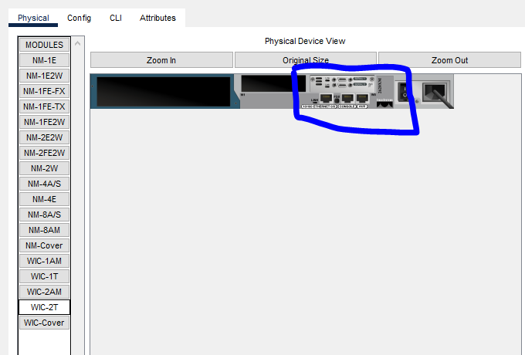

Task 1: Setting up IP addresses
For Router0 (Serial 0/0, Serial 0/1)
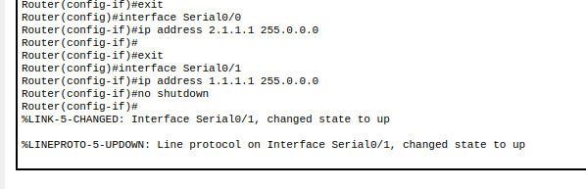
For Router1 (Serial 0/0 and Serial 0/1)
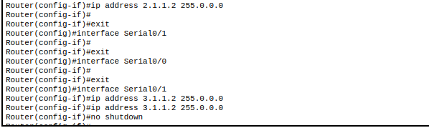
For Router2 (Serial 0/0 and Serial 0/1)
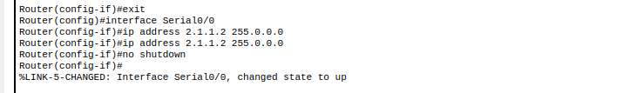
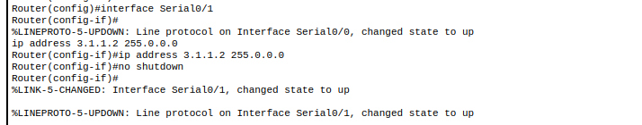
NOTE: Now all links are up. But there is a lot of IP addresses are missing, we need to assign it.
Now, so we need to advertising the missing IPs – dynamically.
On Router0
So connected networks are 1.0.0.0 and 2.0.0.0
Let’s advertise missing networks
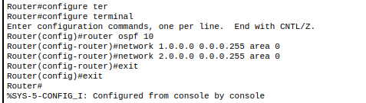
To check

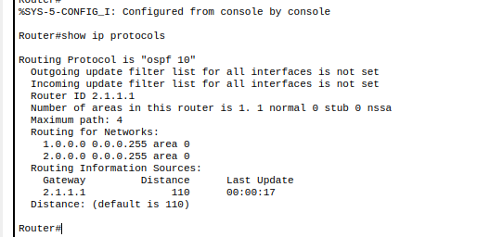
On Router1
So connected networks are 1.0.0.0 and 3.0.0.0
Let’s advertise missing networks

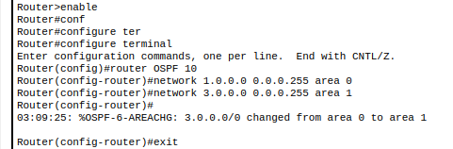

To check
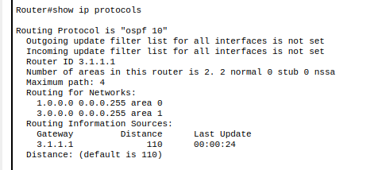
On Router2
So connected networks are 2.0.0.0 and 4.0.0.0
Let’s advertise missing networks

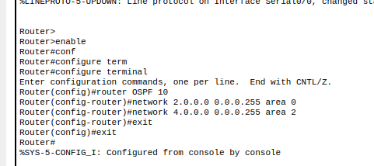
To check
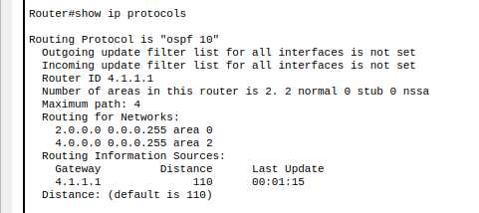
On Router3
So connected networks are 3.0.0.0 and 4.0.0.0
Let’s advertise missing networks
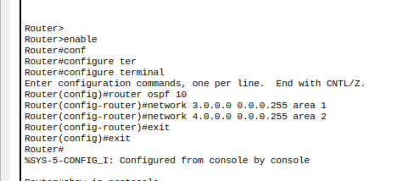
To check
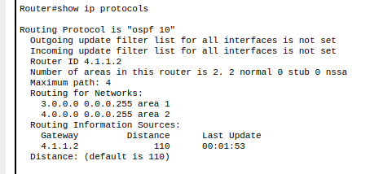
NOTE: we use wildcards instead of subnet masking. (Which is opposite to subnet masking – ON parts will be OFF and vice versa.).
Testing/Result:
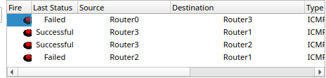

Same Area network can only communicate with each other.
The End

